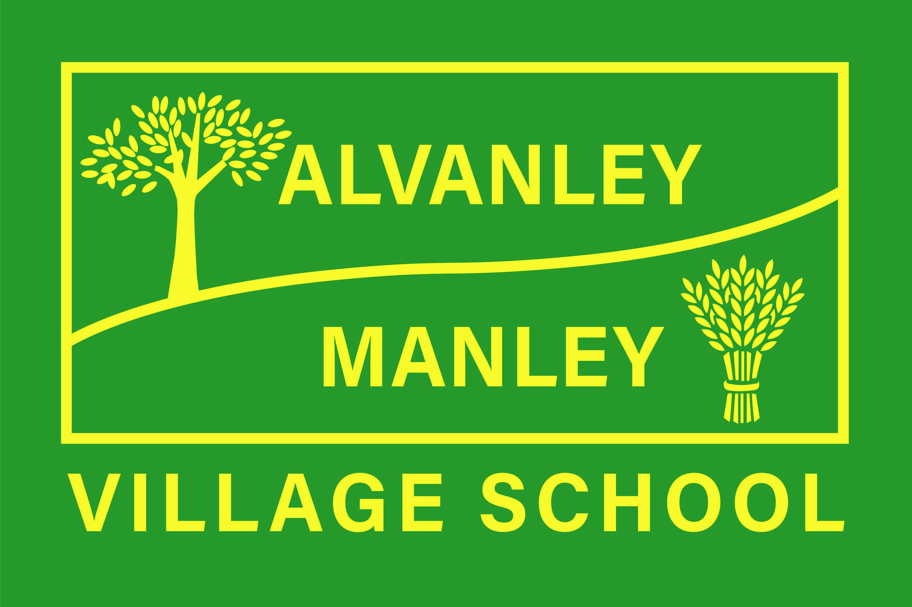
Alvanley Site
Alvanley
Frodsham
Cheshire
WA6 9DD
01244 478021

Tel: 01244 981211

Manley Site
Manley
Frodsham
Cheshire
WA6 9DU
01244 478024

Tel: 01244 981211

Together we nurture, inspire and achieve.

Headteacher: Mr V Thapar
E-mail: head@alvanley.cheshire.sch.uk
head@manley.cheshire.sch.uk
____________________________________________________________________________________________

13th January 2023

Dear Parents,

CLASS 4 TRIP TO JODRELL BANK – THURSDAY 16TH FEBRUARY 2023

In Science, Class 4 are learning about Earth and Space and within our English lesson we are learning about Chris Hadfield who aspired to become an astronaut. You may know him from the music video Space Oddity where he is singing in space. To support our learning of Earth and Space, we will be visiting Jodrell Bank Observatory on Thursday 16th February; the cost of the trip is £18.00. Please give permission for the trip and pay using Parent Pay.

Your child will need:
- School uniform
- Coat
- Packed lunch (Should you wish to order a school packed lunch please email Claire in the office)
- Disposable water bottle

We understand this is a financially difficult time for many, please speak to us or Mr Thapar if you have any concerns in regards to payment.

If you are available to help on the trip, please let Mrs Molyneux know.

Many Thanks

Mrs Molyneux and Mrs Bennett

