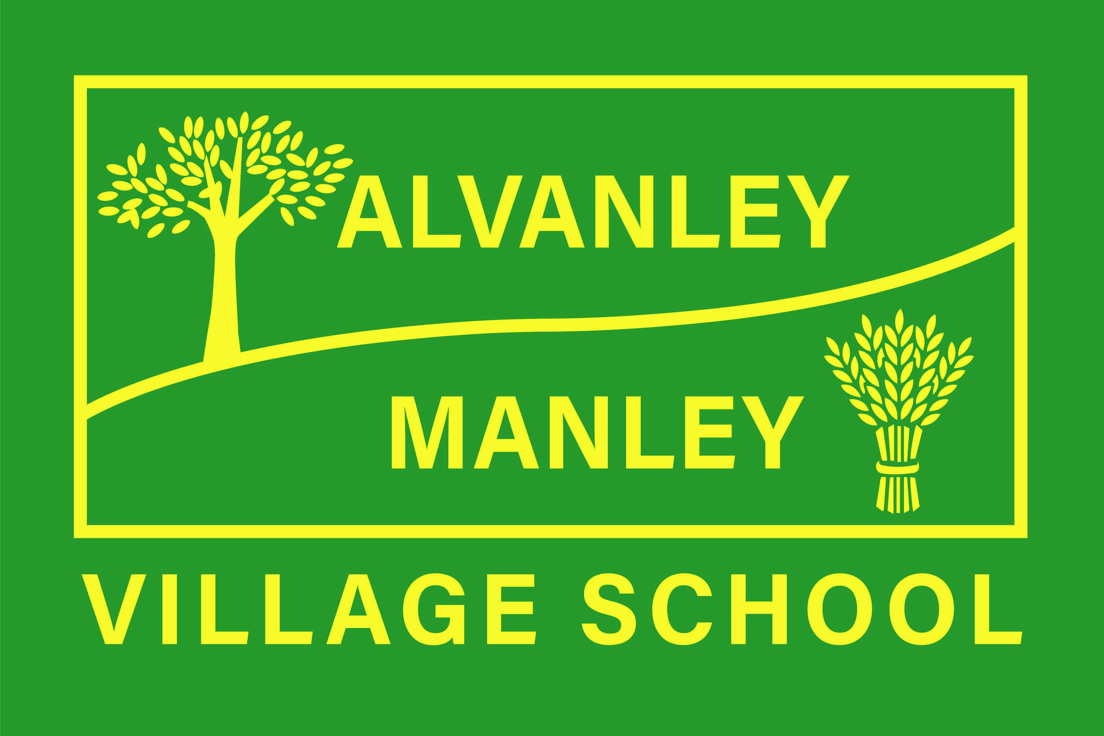
Alvanley Site
Alvanley
Frodsham
Cheshire
WA6 9DD
01244 478021

Tel: 01244 981211

Manley Site
Manley
Frodsham
Cheshire
WA6 9DU
01244 478024

Tel: 01244 981211

Together we nurture, inspire and achieve.

Headteacher: Mr V Thapar
E-mail: head@alvanley.cheshire.sch.uk
head@manley.cheshire.sch.uk
_____________________________________________________________________________________________



Whole School Day –Thursday 9th February
Alvanley Site

Dear Parents,

We are very much looking forward to our whole school Festival of the Arts on Thursday 9th and Friday 10th February. There is a whole school day at Alvanley on Thursday 9th February. Please find below details of the whole school day on the 9th, please note all children will be at the Alvanley site for the day. The children will experience a range of activities to celebrate the arts.

- Drop-off and pick-up Thursday 9th February.
Infant and sibling children should be dropped off at Alvanley between 8.30-8:50am. Infant staff will meet children at the entrance to school and take them into the hall. Junior children should be dropped off from 8.40-9.00am and should go to their normal classrooms.
Infant and sibling children should be collected from the Alvanley school hall at the end of the day from 3:05pm. If parents walk into school on the pathway and turn left towards the main door, keep walking round the left of the building and you will see a set of double doors. Junior children should be collected at 3.20pm from their normal classroom doors.

- Drumming Workshop Thursday 9th February
Each year group will take part in a drumming workshop run by Amasing. Children will be given the opportunity to learn a routine and perform. You are welcome to join us from 2:20pm – 3:00pm for a performance following their workshop.

- The Dot
Children will be reading the story ‘The Dot’ and creating their own pieces of artwork in response to the story. Their work will be submitted to the Royal Academy of Art’s Young Artists Summer Show. Any winning entries will exhibited online and at the Royal Academy of Art in London. Children will also be learning a song and dance that was written in conjunction with the story ‘The Dot’.

- Dance with Miss Clowes – Thursday and Friday
Children will be taking part in a dance session with Miss Clowes, promoting a variety of dance genres and music.

- Sing-a-long with Mrs Curtis – Friday 10th February
Mrs Curtis will be visiting Reception and KS1, with her guitar, to sing some feel good songs for the children to sing and dance-a-long to.

- Brass Workshop and Piano Performances – Friday 10th February
Jacky Keating will be leading workshops with Class 3 and 4 to introduce the children to a range of brass instruments and some of our children will be performing on the piano.

We hope you can join us for this celebration. If you have any questions, please do not
hesitate to get in touch

Mrs Molyneux

