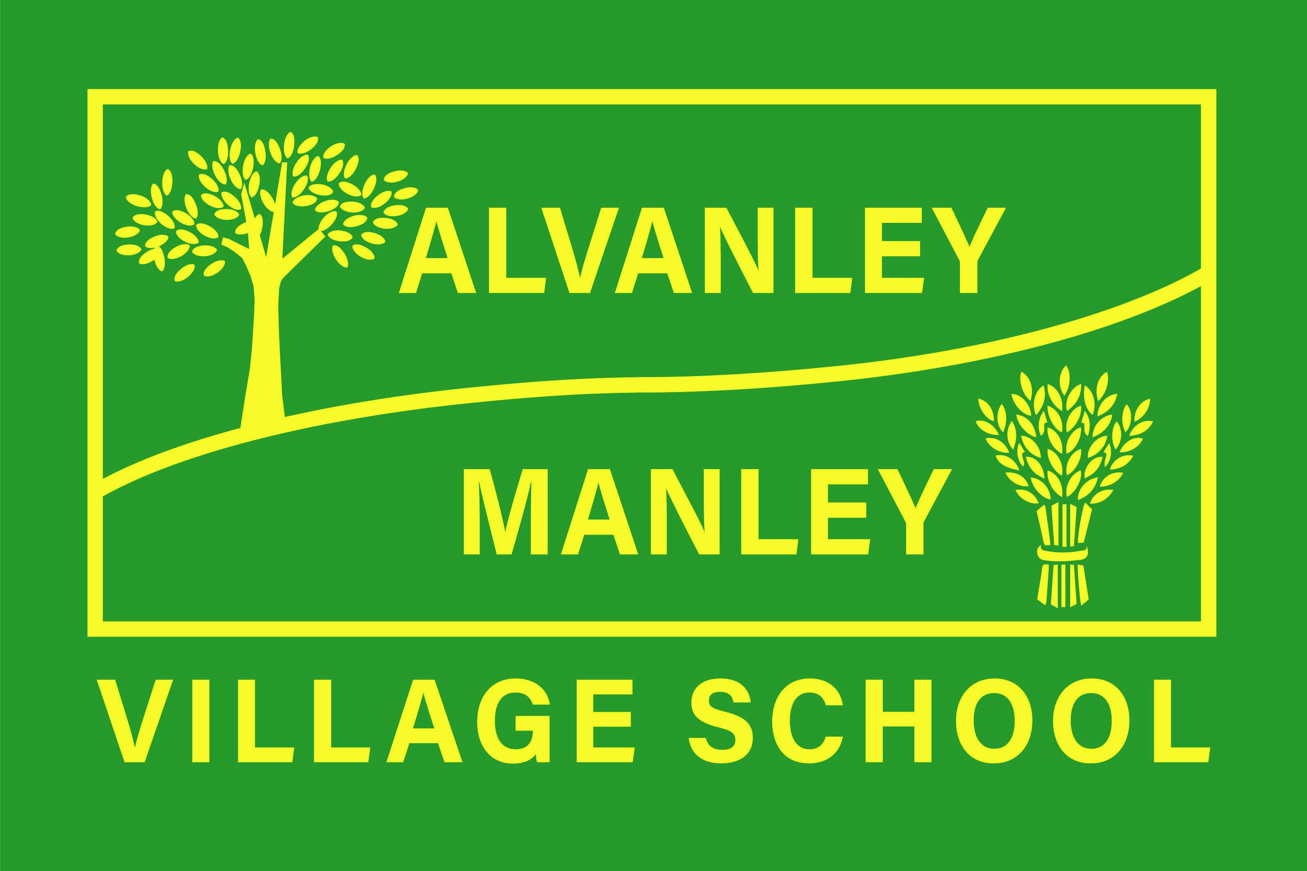
Alvanley Site
Alvanley
Frodsham
Cheshire
WA6 9DD
01244 478021

Tel: 01244 981211

Manley Site
Manley
Frodsham
Cheshire
WA6 9DU
01244 478024

Tel: 01244 981211

Together we nurture, inspire and achieve

Headteacher: Mr V Thapar
E-mail: head@alvanley.cheshire.sch.uk
head@manley.cheshire.sch.uk
_____________________________________________________________________________________________

Important Dates for Spring 2
17th February 2023

Dear Parents,
We hope you have lots of exciting things planned over half term. The next half term in school is a relatively short 5 weeks but we still have lots of events coming up before we break up for Easter. Important dates will also be added to the weekly newsletter, and text reminders will also be sent out whenever relevant. If you have any questions, please do not hesitate to ask your child’s class teacher or email/call the school office admin@alvanley.cheshire.sch.uk / 01244 478021.
For reference: Class 1 – Reception, Class 2 – Year 1&2, Class 3 – Year 3&4 – Class 4 – Year 5&6

Monday 27th February – School reopens for all children.
Monday 27th February – Class 2 Scooter Session
Class 2 children will be taking part in a very exciting scooter session with Sam from Sustrans Travel. Separate information has been sent out with further details. If you have any questions about the session, please get in touch with Mrs Edwards.
Thursday 2nd March – World Book Day
This year’s message is ‘We love to read’. We are inviting children to come to school dressed as a character from one of their favourite books. Outfits don’t need to be brand new – they can be simple and homemade! We are looking forward to a day full of reading and stories. If you would like to come in and take part in our mystery reader event at either site from 2.45pm on the day, please get in touch with Mrs Cupples or Mrs Owens.

Thursday 2nd March – Year 5&6 Dodgeball festival
A group of year 5&6 children will be visiting Frodsham Leisure Centre to take part in a dodgeball festival with other local schools. The event will take place during the school day and we will let you know if your child will be taking part.

Monday 6th March – Reception Hearing and Vision screening
The Reception hearing and vision screening that was booked for this half term was rescheduled last minute. It will now take place on Monday 6th March.
Tuesday 7th and Wednesday 8th March – Parents’ Evening
Our Spring term parents’ evening will be taking place at the Alvanley site for all children from 3.30-6.30pm on both days. Please make sure you log onto your account via the school website to book your child’s slot. Each appointment will last for 10 minutes, and parents will be able to look through their child’s books after their appointment. If you have any difficulty booking your slot, please get in touch with the school office 01244 478021
Thursday 9th March – Year 1 Mini Kickers
Our Year 1 children will be taking part in a mini-kickers event at Helsby High School with children from other local schools. The event will take place during the school day and children will be transported to and from the high school. Year 2 children will remain in school.
Tuesday 14th March – Infant Reading Workshop 2.30pm
Mrs Adams will be running an Infant Reading workshop for parents. A separate letter will be sent out with further information. Mrs Adams will share information about how to help your child with reading at home, and parents will be able to ask questions about their child’s reading.

Friday 17th March – Red Nose Day
This year we will be supporting Red Nose Day again. The theme this year is ‘Mr Men and Little Miss’, so we are encouraging children to come dressed to school as one of the Mr Men or Little Miss characters, or to simply bring in one of the Mr Men or Little Miss books! Please see separate letter that will be sent out with further information and donate to this special cause via the Just Giving link in the letter .
Tuesday 21st March – World Down Syndrome Day
We will be participating in World Down Syndrome Day this year by inviting children to wear brightly coloured socks for the day. We will also be selling ‘Gingerbread Sock Biscuits’ for £1 that have been made by a local family charity. If your child would like to buy a gingerbread biscuit, they can bring in £1 on the day to buy their biscuit.

Friday 24th March – KS2 Cross Country
Our Key Stage 2 children will be taking part in the cross-country event in Delamere Forest again this year. A separate letter has been sent out with more information. If you have any questions about the event, please get in touch with Mrs Owens.
Tuesday 28th March – Year 5 Easter Journey
We are thrilled that our Year 5 children will be taking part in the Easter Journey at Main Street Community Church in Frodsham again this year. During the afternoon, children will be taken to and from the church by coach and will be back in school for home time.

Wednesday 29th March – Year 3&4 Racket skills festival
A group of Year 3&4 children will be taking part in a racket skills festival at Frodsham Leisure Centre. We will let you know if your child will be taking part. Children will be transported to and from the event during the school day.
Thursday 30th March – High Sheriff visiting school
We will be having a very special visitor to both sites during the morning. The High Sheriff will be officially opening the revamped school library at Alvanley before visiting the Infants at the Manley site.

Friday 31st March – Whole School Day at the Manley Site
Our next whole school day will be at the Manley site and our focus for the day will be ‘Science and Art’. All children will spend some time in the forest during the day, hoping to capture some photographs and images of our wonderful surroundings to use and display around the school. Children should come to school in their own clothes, appropriate for our walk into the forest. If any parents have experience in photography and would like to take part in our day or join us on our walk into the forest, please get in touch with Mrs Cupples.
Friday 31st March – School closes for Easter and reopens on Tuesday 18th April.

Yours sincerely
Mrs Cupples

