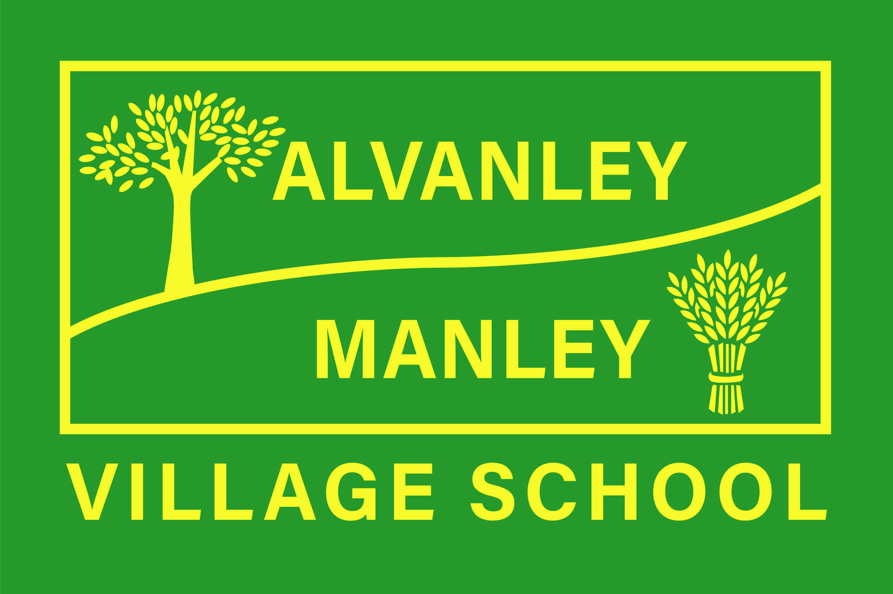
Alvanley Site
Alvanley
Frodsham
Cheshire
WA6 9DD
01244 478021

Tel: 01244 981211

Manley Site
Manley
Frodsham
Cheshire
WA6 9DU
01244 478024

Tel: 01244 981211

Together we nurture, inspire and achieve.

Headteacher: Mr V Thapar
E-mail: head@alvanley.cheshire.sch.uk
head@manley.cheshire.sch.uk
_____________________________________________________________________________________________

17th February 2023

Dear Parents,

To support Red Nose Day on Friday 17th March and to do our bit to raise money, we are inviting the children to be ‘Mr Men’ or ‘Little Miss’ characters for the day. Children can dress up as one of the Mr Men or Little Miss Characters or bring in one of the books to share.

We are asking for a minimum suggested £1 donation per child with all money raised being sent to Comic Relief. Donations should be paid through Just Giving using the link below, please do not send money into school.

https://www.justgiving.com/fundraising/rednoseday23-alvanley-and-manley-village-school-66e5908b-cad1-48b3-b907-da8f6843c328?utm_campaign=lc_frp_share_transaction_transactional_--_page_launched_--_campaign&utm_content=22755f98-1469-455b-b04d-0aec27ae9b52&utm_medium=email&utm_source=postoffice&utm_term=1676323386903

Fundraising activities
Throughout the day, children and staff will be taking part in ‘Mr Men and Little Miss’ activities in order to raise more awareness for Comic Relief. Please see the table below for some of the suggested activities we might be taking part in!

Mr Men and Little Miss Quiz  (Which class will win the most points?) | Power of Funny Riddles! | Mr Men and Little Miss Parade
The ‘Runny Nose’ race | Obstacle Course  (Which teacher can complete the obstacle course in the quickest time?) | Air Guitar Challenge!
Red Nose and Spoon Race | Red Nose Day ‘Danceathon’ | Design a Red Nose ‘Drawathon’

Yours sincerely

Mrs Cupples

