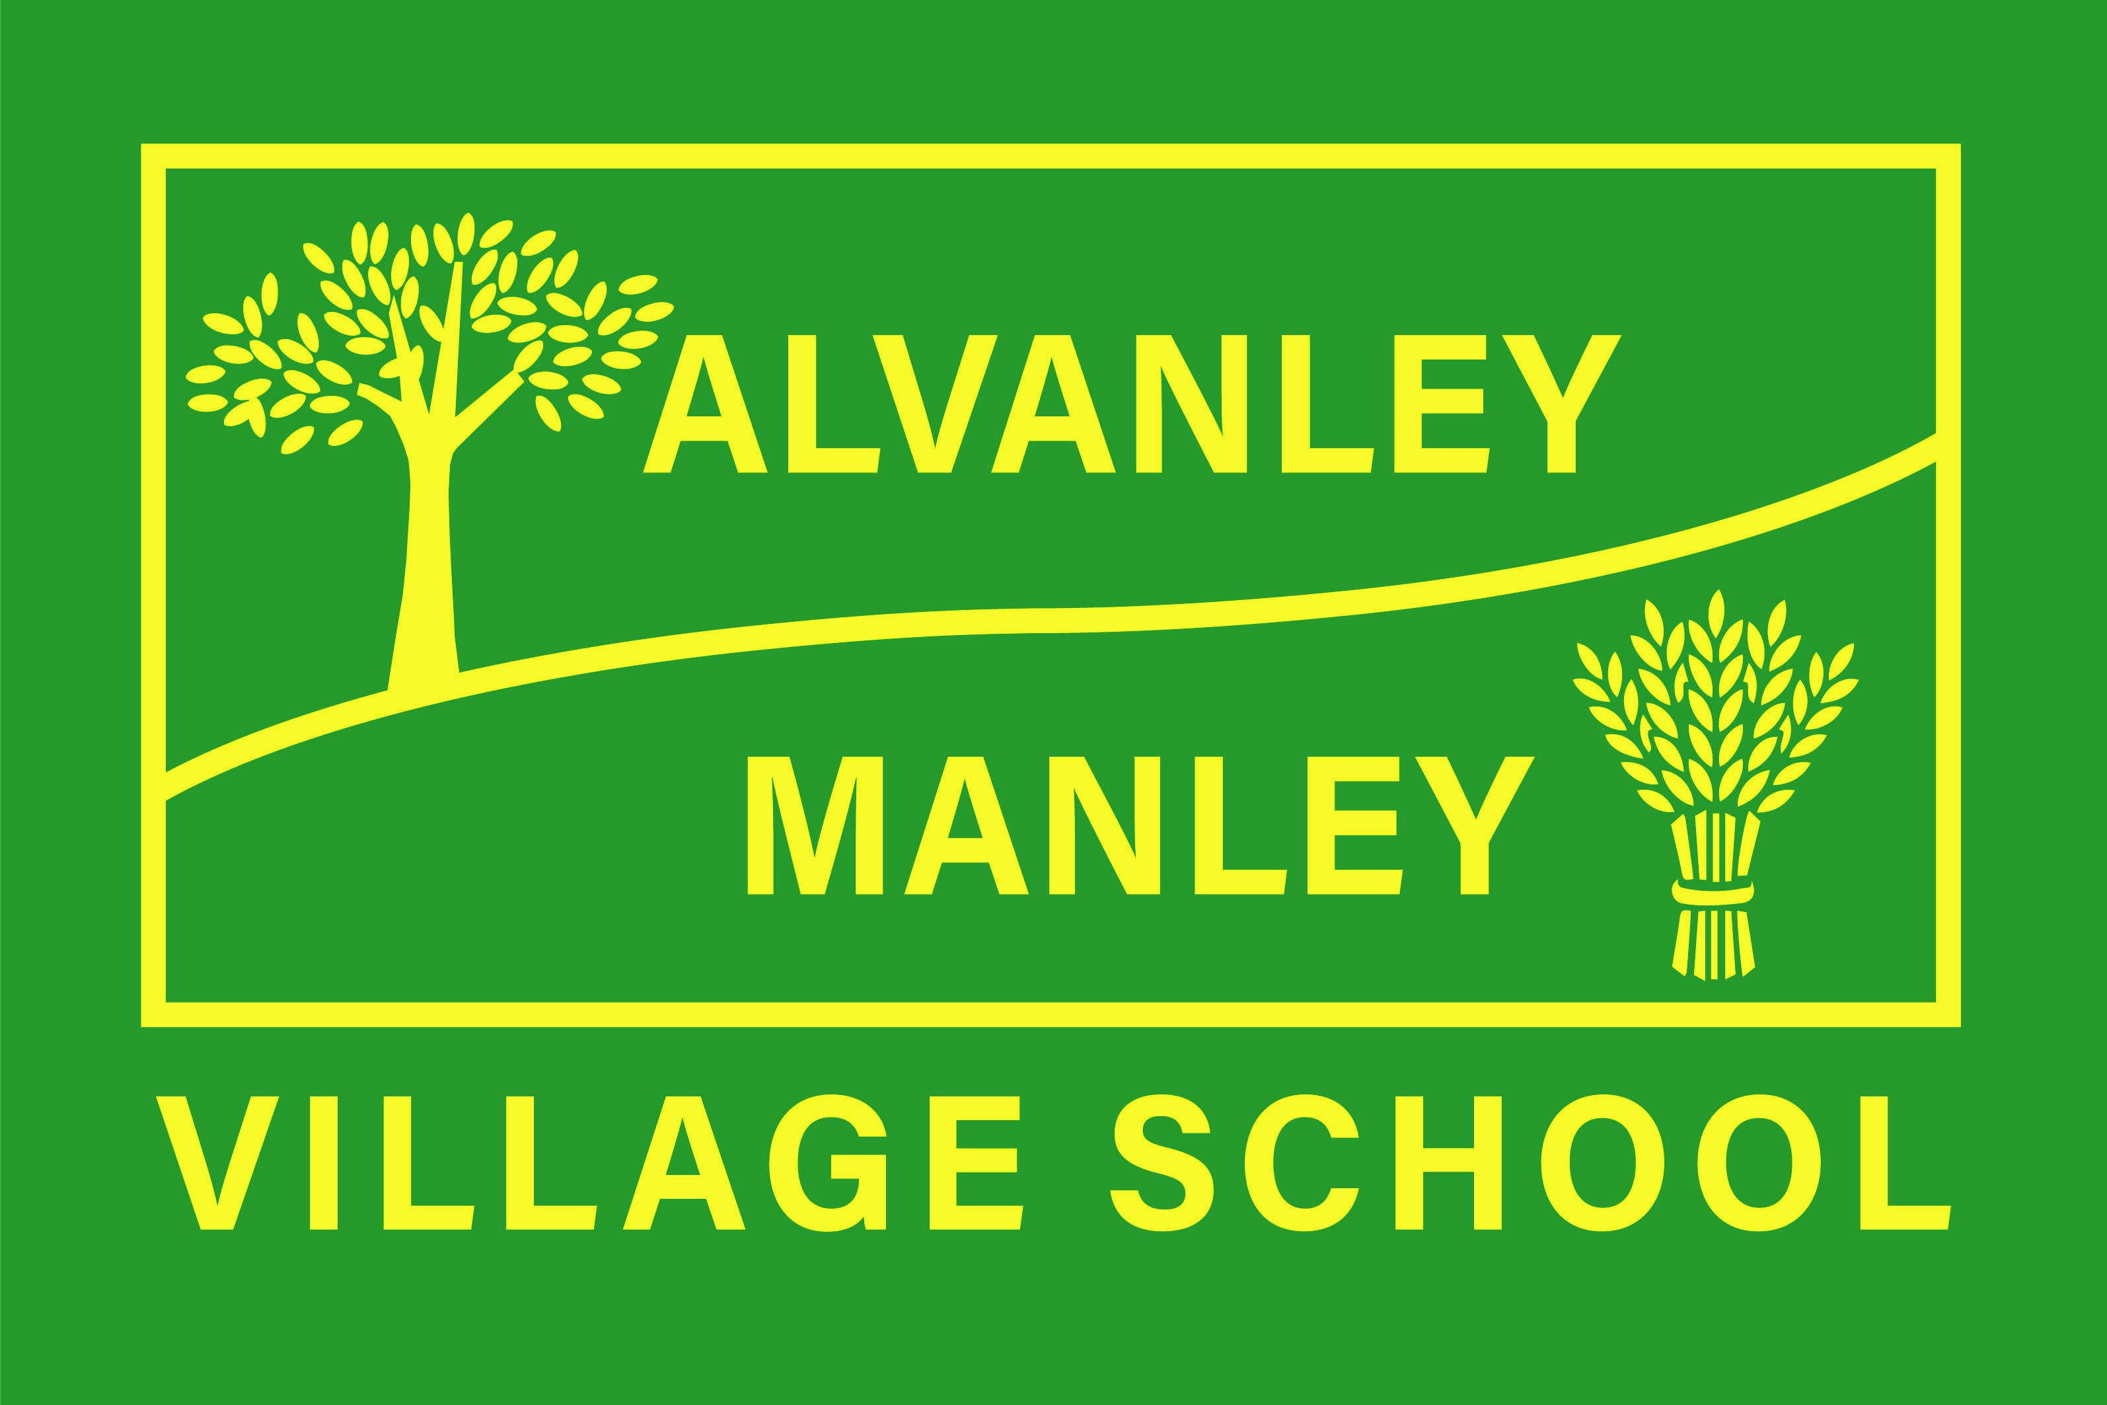
Alvanley Site
Alvanley
Frodsham
Cheshire
WA6 9DD
01244 478021

Tel: 01244 981211

Manley Site
Manley
Frodsham
Cheshire
WA6 9DU
01244 478024

Tel: 01244 981211

Together we nurture, inspire and achieve

Headteacher: Mr V Thapar
E-mail: head@alvanley.cheshire.sch.uk

_____________________________________________________________________________________________

6th September 2023

Dear Parent/Carer

We are continuing with our swimming programme until the Christmas break in December. The lessons will take place at Christleton High School.

This is part of our statutory school curriculum. The National Curriculum requires children at the end of Key Stage 2 to swim unaided, competently and safely for at least 25 metres.

The children in Class 3 will travel by coach to Christleton, leaving school at 9.20am each Tuesday (commencing 12th September) and will return to school before lunchtime.

The children will a require swimming costume, towel and hairbrush/comb in a waterproof bag (please ensure all items are named). Furthermore, I have been asked to draw your attention to an extract from the County Swimming Policy:

- The wearing of any jewellery whatsoever is strictly forbidden. Please ensure that children do not wear earrings on swimming days
- Long hair must be tied back

- The wearing of loose, baggy swimwear is not permissible; especially boys' Bermuda shorts which restrict leg movement. 'Short' shorts will be acceptable. Girls should wear a one-piece swimsuit.

- Goggles may be worn and are advised.

We value this as an excellent chance for children to complete a consistent swimming programme.

During the first session, the children will be assessed and placed in appropriate groups for their lessons.

Any child unable to take part for health reasons must bring a letter of explanation. They will be expected to accompany the group on that occasion and will watch at the poolside.

Please give consent on ParentPay as soon as possible.

Yours sincerely

Mrs Owens

