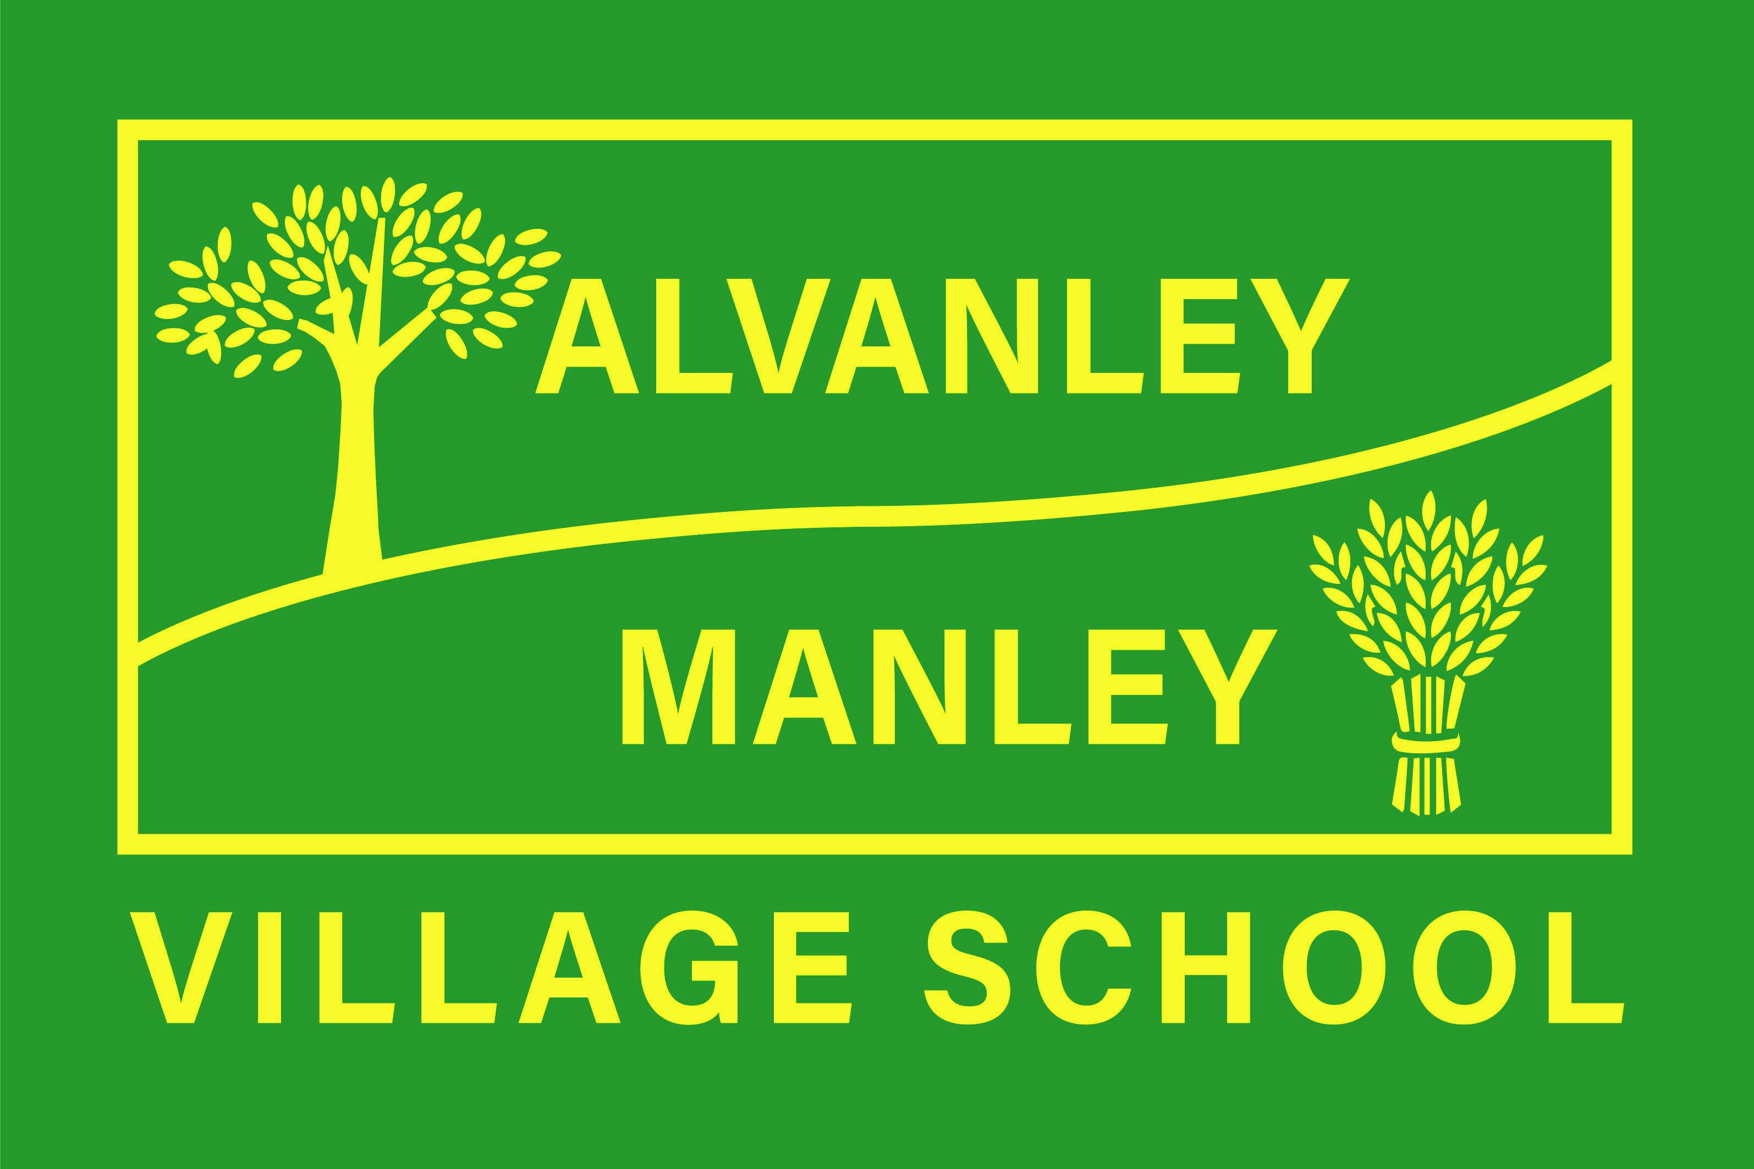
Alvanley Site
Alvanley
Frodsham
Cheshire
WA6 9DD
01244 478021

Tel: 01244 981211

Manley Site
Manley
Frodsham
Cheshire
WA6 9DU
01244 478024

Tel: 01244 981211

Together we nurture, inspire and achieve.

Headteacher: Mr V Thapar
E-mail: head@alvanley.cheshire.sch.uk
_____________________________________________________________________________________________

KS2 Cookery Club

8th September 2023

Dear Parents/Carers,

Hayley from ‘The Adventurous Kitchen’ will be starting her after-school cookery club again for our Key Stage 2 children (Years 3-6) from Monday 18th September. Hayley ran an after-school cookery club in the summer term for Key Stage 2 and it proved popular with all children. The cookery club will run for 5 weeks on Mondays after school, starting on Monday 18th September until Monday 16th October. Each week, the children will produce a themed dish in the club that they will be able to bring home. The club will run straight after school and finish at 4.35pm. The total cost for the 5 weeks will be £27.50 (£5.50 per session).

There are limited spaces on the club, so if your child would like to join, please email the school office admin@alvanley.cheshire.sch.uk as soon as possible. If your child attended the club in the summer term, they are still invited to put their name down, we will just give priority to any children that have not attended before and then offer any remaining places on a first come first served basis. Ms Murphy will get back to those parents to confirm their place. Once all places have been reserved, we will share details of how to pay for your child’s place.

If you have any queries, please do not hesitate to contact school.

Yours sincerely,

Mrs Cupples

