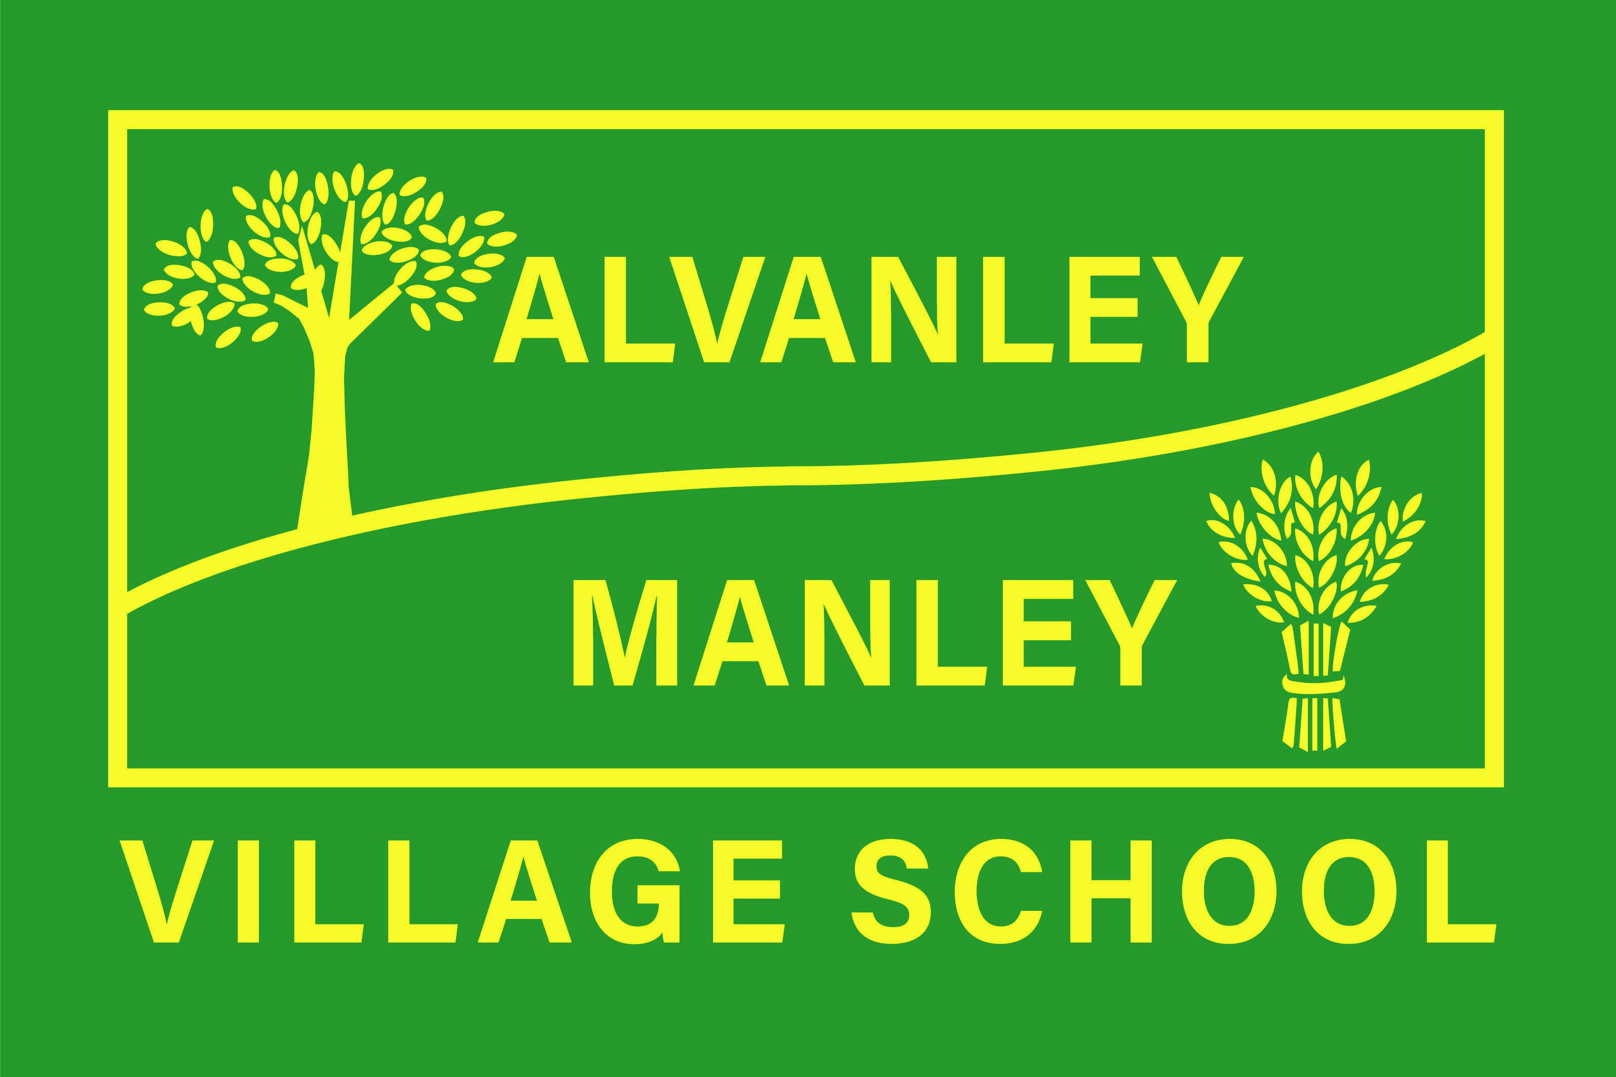
Alvanley Site
Alvanley
Frodsham
Cheshire
WA6 9DD
01244 478021

Tel: 01244 981211

Manley Site
Manley
Frodsham
Cheshire
WA6 9DU
01244 478024

Tel: 01244 981211

Together we nurture, inspire and achieve.

Headteacher: Mr V Thapar
E-mail: head@alvanley.cheshire.sch.uk
_____________________________________________________________________________________________

3rd October 2023
HARVEST CELEBRATIONS

Dear Parents,

We will be holding our annual Harvest Festival in St. John’s Church, Alvanley on Wednesday 18th October at 9:15 am. Our infant children will need to be dropped off at our Alvanley site from 8:30am where they will be greeted and shown to the school hall for registration. The infant children will stay all day and can be collected from 3:10pm.

The children will be leading the service and have been working hard to practise their harvest songs. We would like to extend an invitation for as many parents/carers as possible to join us and share in this wonderful autumnal celebration. It makes such a difference to the children to have you there.

Donations
At Harvest time we think of others and like to share what we have with those who may not be as lucky as we are. We have decided, once again, to support the charity Save The Family by collecting non-perishable food donations for them.

Save the Family provides accommodation and support for families in crisis, in their rural village style community just outside Chester. The charity also supports families in the wider community. The donations we give will help to support these families through the winter months ahead.


Donation Ideas (all non-perishable food items appreciated!)

- Tinned food – soup, meat, beans, vegetables, etc
- UHT milk and fruit juices
- Tea, coffee, squash
- Pasta, rice, pasta sauces
- Toiletries

Donations can be brought into school any time from now and up until our Harvest Service on Wednesday 18th October.

Many thanks for your support,

The Alvanley and Manley Team

