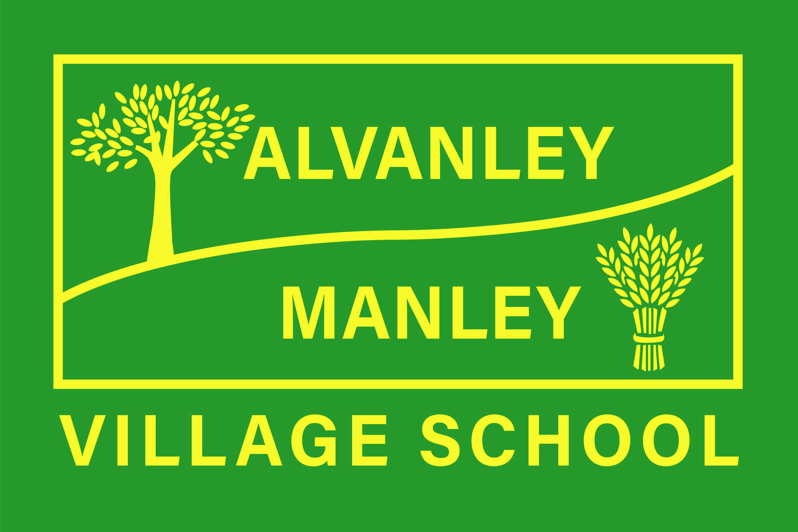
Alvanley Site
Alvanley
Frodsham
Cheshire
WA6 9DD
01244 478021

Tel: 01244 981211

Manley Site
Manley
Frodsham
Cheshire
WA6 9DU
01244 478024

Tel: 01244 981211

Together we nurture, inspire and achieve

Headteacher: Mr V Thapar
E-mail: head@alvanley.cheshire.sch.uk
head@manley.cheshire.sch.uk
_____________________________________________________________________________________________

Monday 5th September 2022
Welcome Letter
Dear Parents,

May I welcome you all back to a brand new school year with lots to look forward to on the horizon. I hope you have had an enjoyable and restful summer but like us, are glad to be back! May I also extend a warm welcome to our new Reception parents; please do get in touch if you have any questions or queries, we are more than happy to help!

For those who may have missed the end-of-term letter, please be aware that a key focus for the local authority is attendance; it is essential that this improves both locally and nationally in 2022-23 and the local authority will be being much more stringent with unauthorised absence. A key focus in school is uniform – please make sure your child is wearing the correct uniform, especially footwear, (see website if unsure) and has their PE kit in school on the correct days.

We are all acutely aware of the forecast impact of higher energy prices and of how this may lead to significant challenge within our families. As a school, we try to plan many exciting experiences for our children with both visits out and visitors invited into school. If you find you are struggling with the cost of these then please do get in touch – we will do whatever we can to support you.

Joining our team this September is Rebecca Matzen who has been appointed as the School Bursar and will work alongside Claire Murphy, our Administration Assistant. Also officially joining the team is Mark O’Reilly as the school’s new Site Maintenance Officer. We wish them both well in their new respective roles.

Again, as a reminder to most parents, we are a nut-free school and continue to ensure the safety of all of our children by being vigilant when looking at ingredients in our school lunches. We do very much appreciate your support in this when putting together packed lunches and / or choosing healthy snacks.

A separate letter with dates of events for the half term will be sent out but may I highlight our annual Coffee Morning, which will be taking place in the Manley Dining Hall on Friday 30th September for Macmillan Cancer Support and our ‘Hello Yellow’ Day for Mental Health on Monday 10th October.

Regards,

Mr Thapar
Head Teacher

